Dordt College Engineering Department
Faculty Course Assessment Report

Course: EGR 322, Electronics I
Instructor: Douglas De Boer
Semester: Fall 2010

Catalog Description:
EGR 322, Electronics I, (4 credit hours) A study of the flow of electricity in, and application of, semiconductor devices. Topics include operational amplifiers and frequency response, diode circuits, bipolar junction and field effect transistors, current sources, biasing, current mirrors, small signal analysis, single and multistage amplifiers, and feedback. The laboratory includes a number of short design problems. Prerequisite: EGR 220.

Grade Distribution
Semester | Instructor | A | A– | B+ | B | B– | C+ | C | C– | D+ | D | D– | F | WP | WF | Total
F 2010 | De Boer | 2 | 3 | 1 | 1 | 1 | 1 |  | 2 |  |  |  |  |  |  | 11
F 2008 | De Boer | 4 | 2 | 1 |  |  | 2 |  |  |  |  |  |  |  |  | 9
F 2006* | De Boer |  |  |  | 3 |  |  | 1 |  |  |  |  |  |  |  | 4
F 2004* | De Boer | 4 |  |  | 3 |  |  | 3 |  |  |  |  |  |  |  | 10
*Prior to August 2007, only straight letter grades were recorded by the registrar.

Modifications Made to Course
For the fall of 2010 the textbook was updated from the fifth edition to the sixth edition of Sedra & Smaith’s Microelectronic Circuits This re-ordered the content but otherwise there were only small changes.

Course Outcomes Assessment
Creational Structure: Students will understand elementary semiconductor device physics at the level of equations which model the terminal characteristics of diodes and transistors. This means that students will be able to represent a diode or transistor circuit via a well labeled schematic drawing, derive appropriate equations from the schematic, and know how to solve those equations. This will be the main goal of this course. Additional goals are listed below.
The above outcome was achieved as evidenced by performance on tests and results on a student evaluation of the course.
Creational Development: Students will be able to apply several design techniques for stabilizing bias levels. They will understand tradeoffs involved in choosing a bias technique. Students will be able to design circuits involving one or two transistors used in well-known configurations such as a current mirror, cascode amplifier, feedback amplifier, etc. They will understand a historical perspective of how these techniques have improved over time.

The above goal was achieved as evidenced by performance on tests.

(continues on the next page)

Program Outcomes Assessment

Teamwork: The students worked in teams of two on the lab projects.

Problem Solving and Critical Thinking: The lab projects required problem solving and critical thinking to evaluate which of several different solution techniques should be used. There were also open-ended homework assignments.
Communication: Students wrote a lab report.

Engineering Design: Students participated in teams (two students per team).to design an amplifier in a lab project. Some homework problems were also design oriented. .

Engineering Skills and Tools: Students solved homework problems. PSpice was required in the lab and used by some students for the lab projects.

Student Feedback
Student feedback was collected via three surveys. (My courses sure were assigned a full dose of surveys this semester!) These survey results are detailed on the last several pages of this document.

1.) IDEA forms.
Progress on relevant objectives was higher than average. “Raw” rank this course “higher” or “much higher” in all categories. “Adjusted” scores rank the course as “similar” to other courses. Note that adjustments to the raw scores are based mainly on student motivation (higher motivation results in downward adjustments), and student work habits (better work habits result in downward adjustment). To a lesser extent, class size is also a factor (smaller classes result in downward adjustments). Adjusted scores thus rank the class including factors that are beyond the instructor’s control. (The IDEA Center, Technical Report 12, available online from http://www.theideacenter.org. See especially Section III.)

Reflection
The new edition of the textbook is a blessing to our students. It’s organization of delaying frequency-response studies to the second semester (EGR 323 Electronics II) helps the students get the fundamentals well. The homework loads were seen by the student as more uniform and sequential.

The lab portion of the course, as has been the case for a decade, still has a lot of potential for improvement. The heavy reliance on project work means the some of the students who most need to learn design and simulation skills, and even general project planning, rush ahead and build things without adequate modeling and design. Then they spend inordinate amounts of time troubleshooting while not learning much. While the students apparently like the flexibility and challenge of lab projects, some preliminary directed lab work could help.

This semester all of the students in the course had experienced the “peer grading” style of instruction used in EGR 220. This helped students quickly adapt to the classroom discussion based on homework assignments that makes up a majority of the class time in this course.

Proposed Actions for Course Improvement
1.) Devise “read-and-do” (directed but not graded) lab activities to demonstrate particular concepts, for one example, the reuse of models. Redo the lab schedule to make time for these activities. While this improvement would be desirable, it might to be efficient enough use of the instructor’s time to justify it.

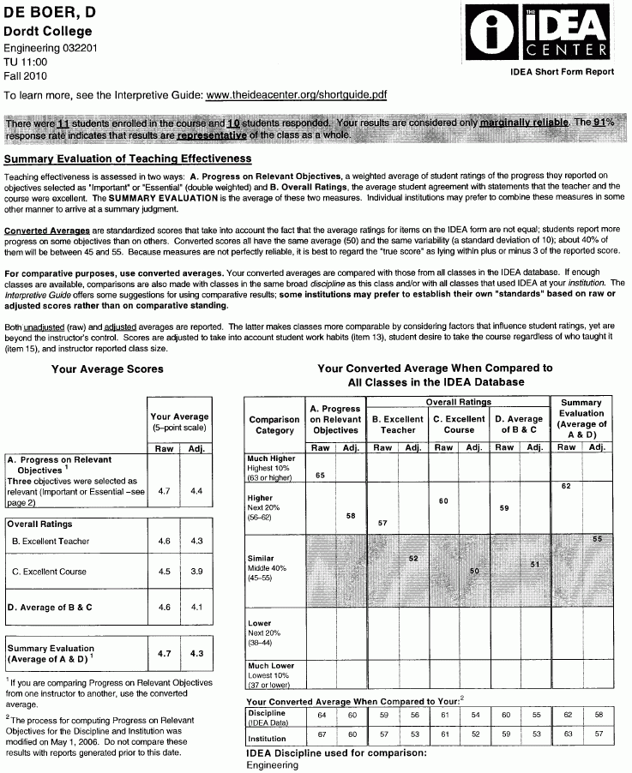

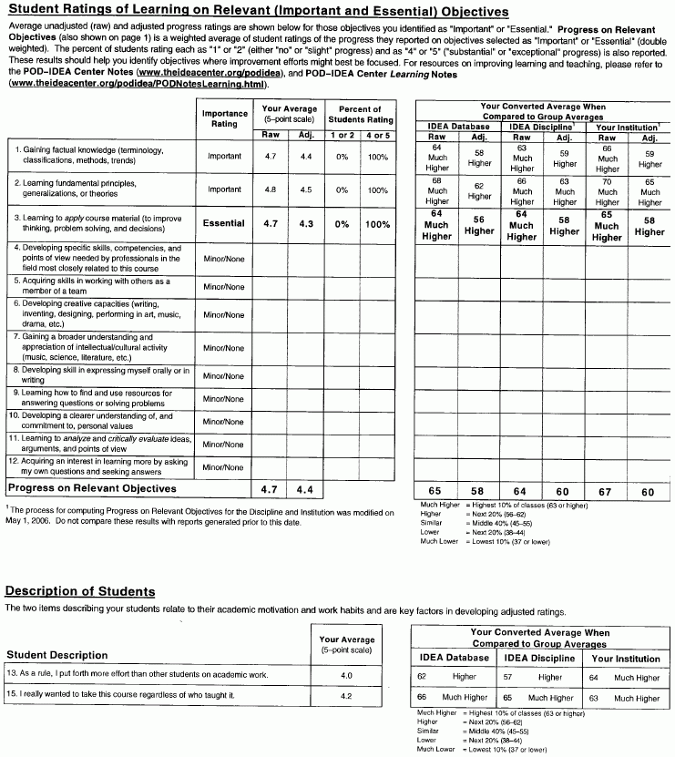

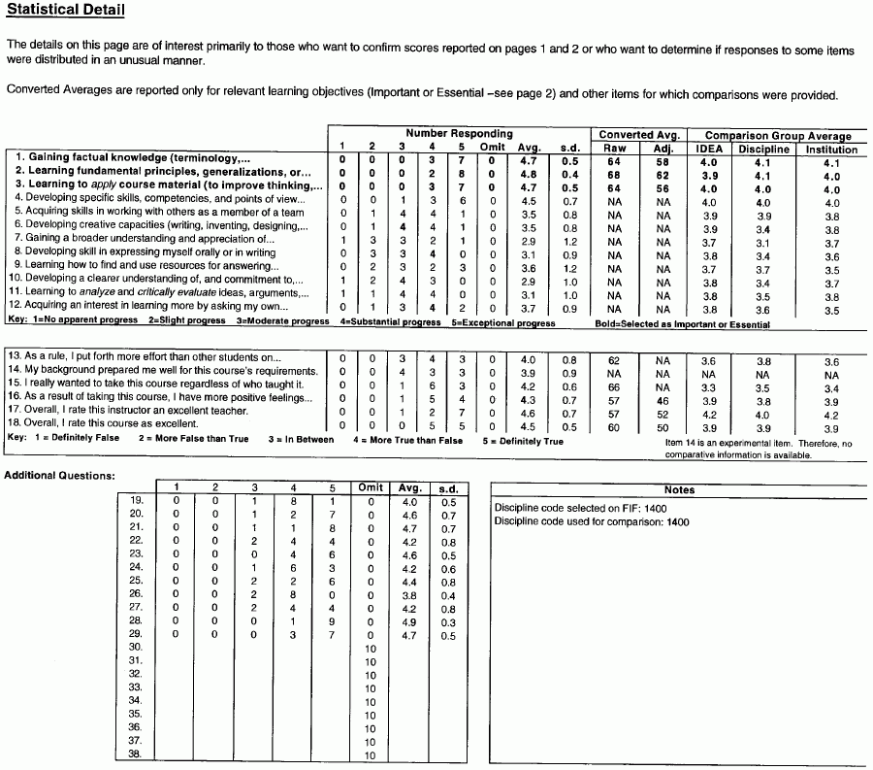

EGR 322
Electronics I

Extra questions to accompany the IDEA Center Survey Form
(Numbers in parenthesis are the average results on a scale of 1 to 5.)

Please respond by marking the “Extra Questions” area of the IDEA forms.
Written comments in response to these questions may be placed on the back of your IDEA form. Any responses written on this page will be ignored. This page will be recycled.

For these questions, use the following code:
(The same code is shown on the IDEA form)
1 = Definitely 2 = More False 3 = In Between 4 = More True 5 = Definitely
False Than True Than False True

19. (4.0) I understand how holes and electrons behave near a semiconductor junction.

20. (4.6) I understand how the current through a diode depends on the voltage applied to the diode.

21. (4.7) I understand the regions of operation of field effect transistors. Given a sufficient number of voltages and/or currents, I can figure out which region of operation best models the behavior of the transistor.

22. (4.2) I understand how to apply my knowledge of circuit analysis to find the terminal voltages and currents of a transistor in the context of an amplifier circuit.

23. (4.6) I understand what the concept of small-signal analysis is.

24. (4.2) I can apply the concept of small-signal analysis to a circuit that has a field effect transistor.

25. (4.4) I know what the advantages and disadvantages of a common source amplifier are.

26. (3.8) I know what the advantages and disadvantages of a common gate amplifier are..

27. (4.2) I know what the advantages and disadvantages of a common drain (also called a source follower) amplifier are..

28. (4.9) I understand the limits and advantages of modeling and the importance of laboratory prototyping.

29. (4.7) This course gave me a greater appreciation for the study of electronics.

Course Number/Name: EGR 322 Electronics I Instructor: _De Boer_F 2010

Your response to this course and the instructor are used for two purposes:
- To help the instructor improve his/her course and teaching
- To serve as one piece of information to evaluate instructor’s teaching effectiveness.

Please print your name in the space above; your name will be removed before the instructor sees your responses. If you do not sign the form, your responses will not be considered.

ADDITIONAL QUESTIONS FOR STUDENTS

1. What should the instructor continue doing that is helpful for your learning?
“Pacing of the courses was good. Majority of time devoted to homework was helpful. Interstates, Ribeiro sessions [invited guest speakers] were very good. Good testing philosophy: difficult but with heavy curve.”
“Accepting questions during class time on homework that helps me out a lot.”
“Lab Work, Problem Sets, Example Problems”
“Using the time in class for both answering questions + lecturing. This balance was crucial to our understanding + let us get a grasp on what we would be learning next.
“Willingness to help the students at any time. Office that is always open!”

“I personally prefer the problem solving approach to class. Less lecture, for me, is more beneficial, but I understand there is a balance.
“Continue to answer questions. I find this to be some of the most helpful material. Continue courses@dordt. Continue the openness of your office.”
“Teach me outside of class”
explanations, answering questions, reviewing theory when applicable, pacing of the workload, putting detailed answers online to supplement my understanding of the material.”

2. What should the instructor change or stop doing because it is not helpful to your learning?
“Sometime going through thing you can go off on a tangent + I get a little lost.”
“Nothing—overall was a good class”
“N/A”

“Nothing”
“I think keeping it a MWF class would be wise.” [This class was a Tu Th class due to room scheduling issues.]
“Putting this question here”

3. What additional suggestions do you have for your instructor?
“Possibly more real world examples of the elements we are studying.”
“Sometimes it’s hard to determine whether I have fully understood the concept. so problems or exercises that might help to see what I am missing will be helpful.
“It took me a while to get used to the Midwestern/Christian education, but now that I’m used to it, my opinions of you and Dordt have improved as well as my ability to understand the teaching styles.
“Keep up the thrashingly difficult test. They are more fun.”
“One improvement to this course would be to make the lab projects a little more applicable. For example, instead of just making a CS amplifier, make it and then amplify and audio signal.”
“Continue the ‘random’ tangents of class not all of life is homework and studies and I appreciate some of your insights.”
“Survey your students to see if they are really understanding.”

4. How has this course and your instructor’s efforts shaped or deepened your understanding of this
subject from a biblical perspective?
“Good emphasis on philosophy of EE. Why do it?”
“I see it as another class where I am exploring God’s creation and trying to understand as much of it as I can.”
“Encouraged us to view our work as service for other and encouraged us to express our faith in everything we do, including engineering.
“From this class, I saw how God’s creation can be used by man to make many different electrical components. I was interesting to see how such small devices in electronics can be made to perform tasks that otherwise would seem impossible.”
“People’s willingness to learn and develop more and better technology under God’s allowance is very awesome!”
“Dr. De Boer has always benn a proponent of living a social and spiritual lifestyle along with engineering.”
“Engineer is not limited to narrow areas of math + science but involves many aspects of society and creation.”
“I have learned more about another aspect of God’s creation.”
“Stay true to my morals in the workplace.”

